DSA0602 DATA HANDLING AND VISUALIZATION
CLASS ACTIVITY 4
NAME:ARCHANA J
REG NUMBER:192324294
DATE:07.08.2026
QUESTIONS:
1. A university wants to determine whether students who spend more hours studying obtain higher marks.
Dataset
StudyHours Marks
2 45
3 52
4 58
5 63
6 69
7 74
8 81
9 88
Task
• Create the dataset in R.
• Draw a scatterplot.
• Add axis labels and title.
• Interpret whether a positive correlation exists.
CODE:
library(ggplot2)
data <- data.frame(
StudyHours = c(2, 3, 4, 5, 6, 7, 8, 9),
Marks = c(45, 52, 58, 63, 69, 74, 81, 88)
)

ggplot(data, aes(x = StudyHours, y = Marks)) +
geom_point(color = "blue", size = 3) +
labs(
title = "Study Hours vs Marks",
x = "Study Hours",
y = "Marks"
) +
theme_minimal()
OUTPUT:
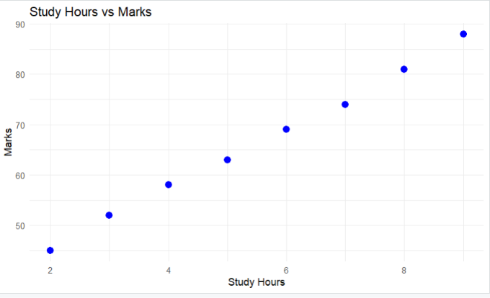
2. A hospital records patients' age and systolic blood pressure.
Write a Python program using Matplotlib to:
Create a scatterplot.
Display gridlines.
Change point color to red.
Comment on the observed trend.

library(ggplot2)

data <- data.frame(
Age = c(25, 30, 35, 40, 45, 50, 55, 60),
BloodPressure = c(110, 115, 120, 128, 132, 138, 145, 150)
)

ggplot(data, aes(x = Age, y = BloodPressure)) +
geom_point(color = "red", size = 3) +
labs(
title = "Age vs Systolic Blood Pressure",
x = "Age (Years)",
y = "Systolic Blood Pressure (mmHg)"
) +
theme_minimal()
OUTPUT:
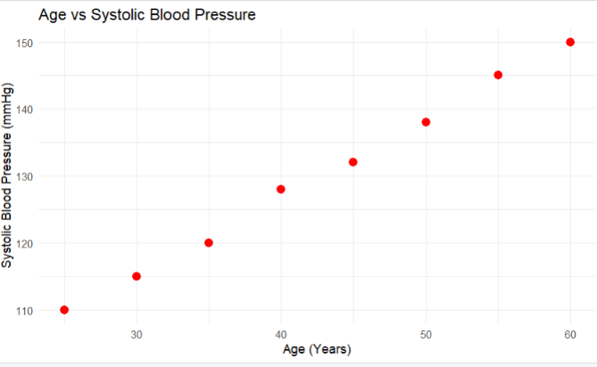
3. A company wants to investigate whether advertising expenditure influences monthly sales. Develop a scatterplot and determine whether sales increase with advertising expenditure.
A financial institution has collected information on:
Income
Savings
Loan Amount
Credit Score
Generate a correlation matrix and visualize it using a correlogram.
Which variables exhibit the strongest positive correlation?
library(corrplot)

finance <- data.frame(
Income = c(25000, 30000, 35000, 40000, 45000, 50000, 55000, 60000),
Savings = c(5000, 7000, 9000, 12000, 15000, 18000, 21000, 25000),
LoanAmount = c(20000, 25000, 28000, 32000, 35000, 38000, 42000, 45000),
CreditScore = c(620, 650, 670, 700, 720, 750, 780, 810)
)

cor_matrix <- cor(finance)

print(cor_matrix)

corrplot(
cor_matrix,
method = "color",
type = "upper",
addCoef.col = "black",
tl.col = "black",
tl.srt = 45
)
OUTPUT:
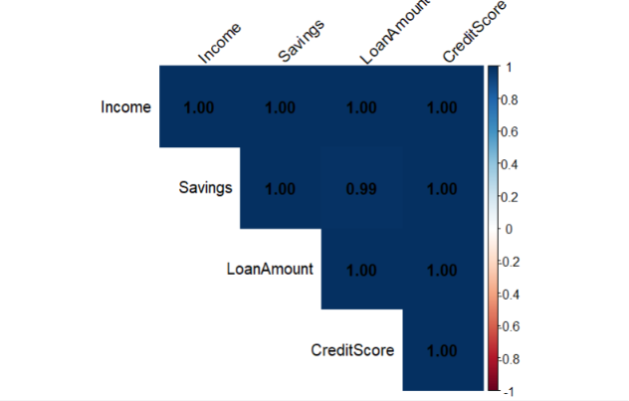
4. A financial institution has collected information on:
Income
Savings
Loan Amount
Credit Score
Generate a correlation matrix and visualize it using a correlogram.
Which variables exhibit the strongest positive correlation?
CODE:
# Install once (skip if already installed)
install.packages("corrplot")

# Load package
library(corrplot)

# Create dataset
finance <- data.frame(
Income = c(25000, 30000, 35000, 40000, 45000, 50000, 55000, 60000),
Savings = c(5000, 7000, 9000, 12000, 15000, 18000, 21000, 25000),
LoanAmount = c(20000, 25000, 28000, 32000, 35000, 38000, 42000, 45000),
CreditScore = c(620, 650, 670, 700, 720, 750, 780, 810)
)

# Correlation Matrix
cor_matrix <- cor(finance)

print(cor_matrix)

# Correlogram
corrplot(
cor_matrix,
method = "color",
type = "upper",
addCoef.col = "black",
tl.col = "black",
tl.srt = 45
)
OUTPUT:
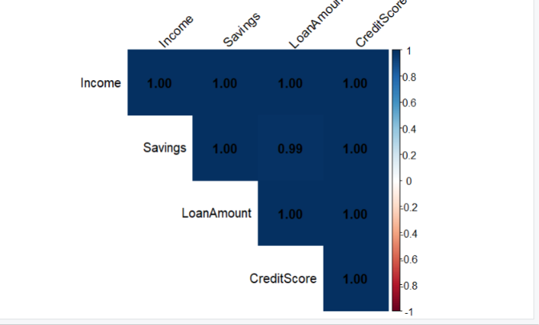
5. Using the Iris dataset,
Compute the correlation matrix.
Display it as a heatmap using Seaborn.
Identify variables having negative correlation.
CODE:

